*I think this problem is related to drawing the loss curve. Students should carefully check the save function in* [*utility.py*](http://utility.py/) *to make sure there exists model files and event files in that folder*

Dst folder:

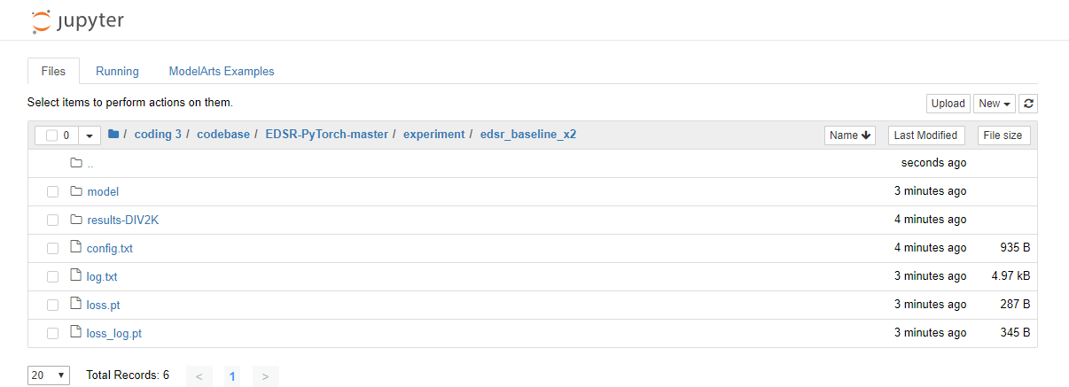

Error: look in file “error v2.txt”

My file “utility.py” is here too.